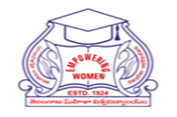
University College for Women
Koti, HYDERABAD
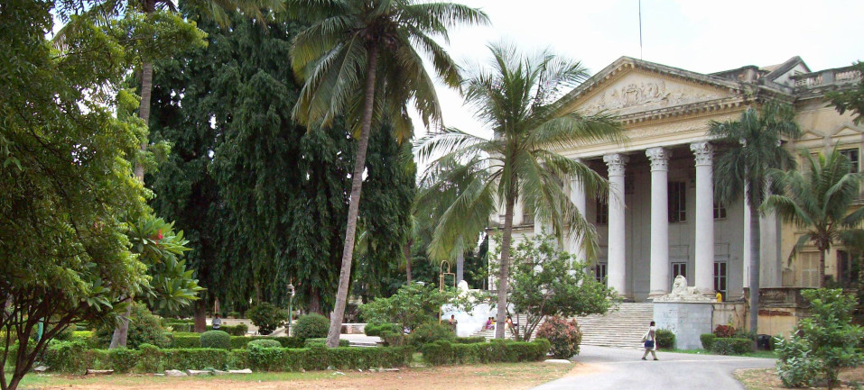
Human Capital Development Centre
A REPORT on Activities (2021-22)
ENTREPRENEURSHIP & CAREER MENTORSHIP PROGRAM, 8th DECEMBER 2021

HCDC has organized “ENTREPRENEURSHIP AND CAREER MENTORSHIP PROGRAM” in association with Ms. M. Shamantha Rani, founder of Sector Seven on 8th December, 2021 at 12:00pm, with an objective to expose the students to the world of entrepreneurship. Ms. Shamantha spoke vastly about various careers; the skills needed to match each specific career and discussed how the students can upgrade themselves to match the said skills.
Ms. Shamantha then went on to introduce the incubation centre run by her and gave a detailed description of how the centre helps students prepare themselves to meet the rising demands of the global employment market.
The students shared their dreams and goals and sought advice on the pursuit of certain careers. The session was attended by 300 undergraduate fifth semester students and was highly useful forgiving a direction to their goals.

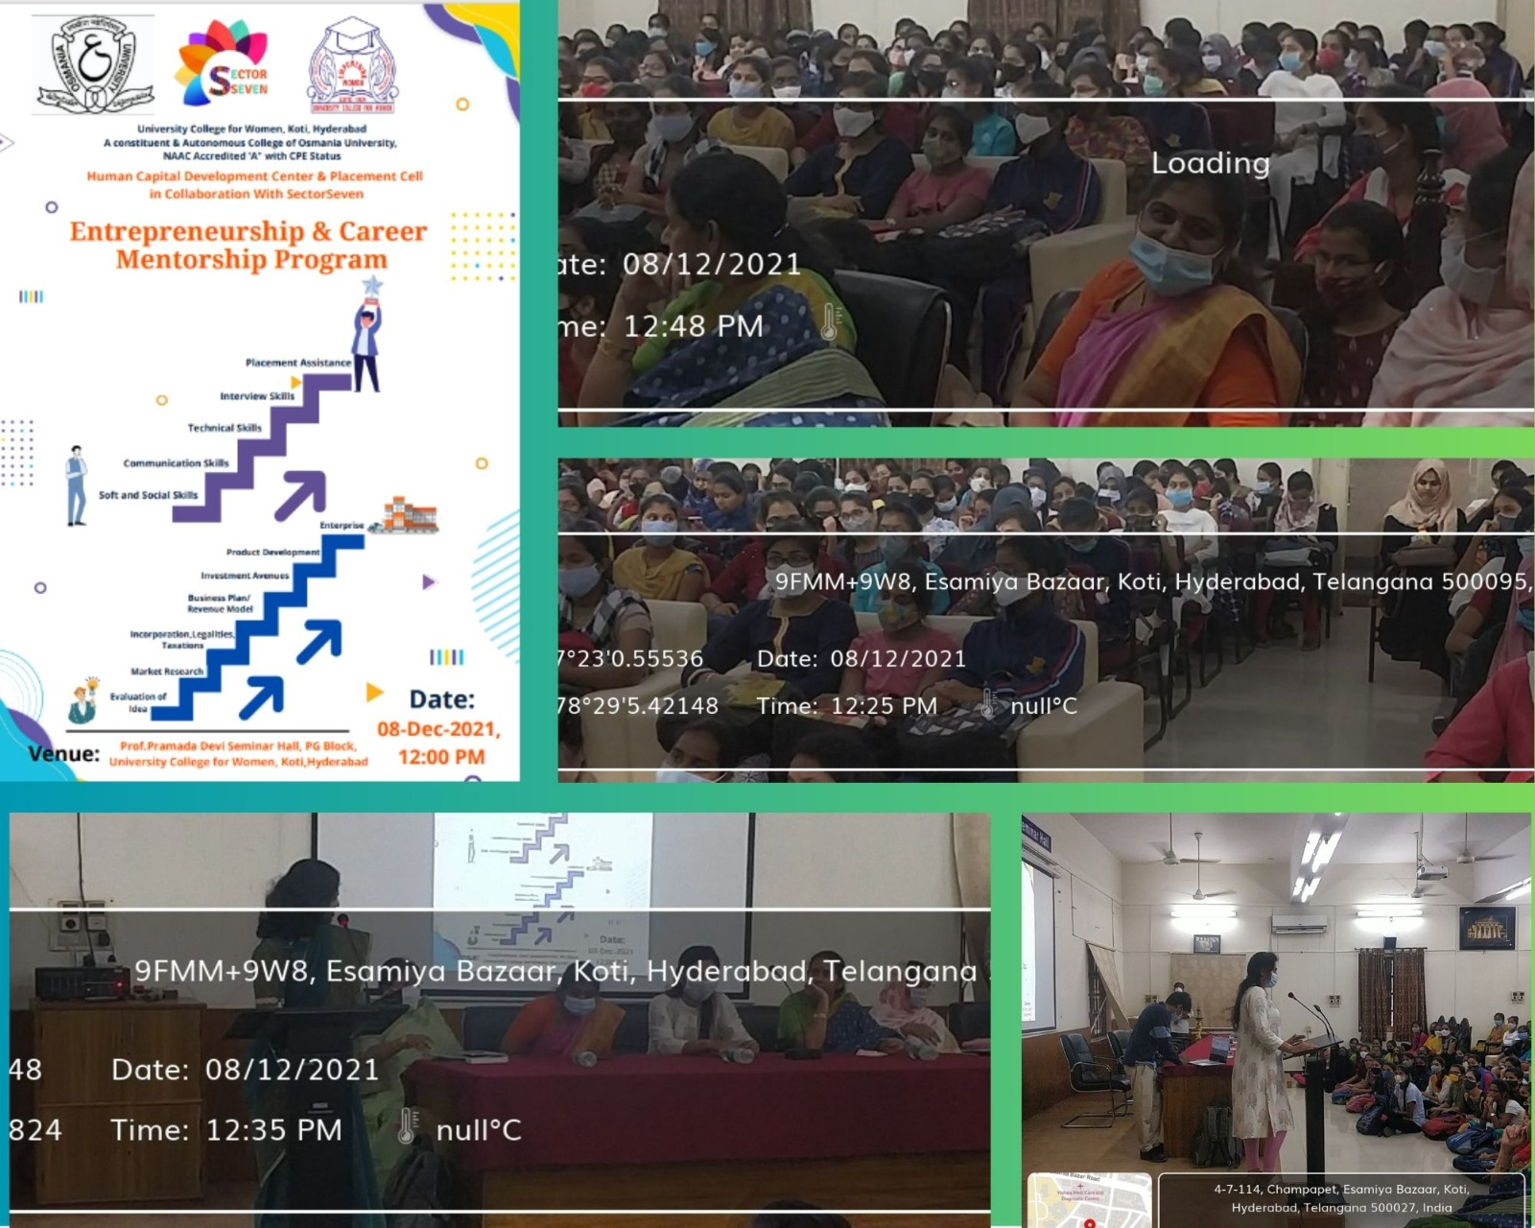
Five Day PRE-PLACEMENT TRAINING PROGRAM, 13th -17th December 2021
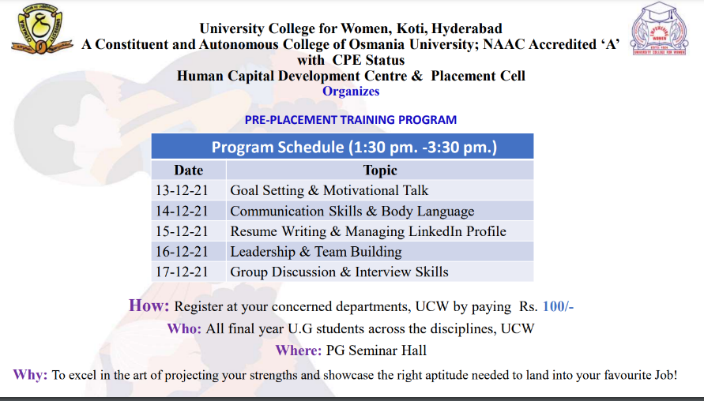
The main objective of the Pre-Placement Training is to expose students to the Corporate Culture and explain them the processes followed there and to make them comfortable when they are exposed to it. To make them realise the importance of a A-Z soft skills, Resume, communication and behaviour. To help them understand the nuances of Group Discussions theoretically and practically.
Day 1: (13th Dec, 2021)
Dr.GLK. Durga began the session on the topic Goal Setting and Motivational Talk in a unique way by using alphabets from A to Z. She explained every letter with real-life examples by using songs, jokes and stories. She gave a detailed overview of interpersonal skills, knowledge, leadership, how to be optimistic and how to achieve someone’s predetermined goal.
She also explained ethics, group work, negotiation skills and professionalism. She told students not to leave work to the last hour i.e., not to procrastinate and to prioritize a to-do list. She said that setting goals helps a person remain focused on being successful, stay away from distractions, and will help with motivation. The session was attended by 290 students of UG and P.G. It was a great experience for the students and they stayed bright and cheerful all through.

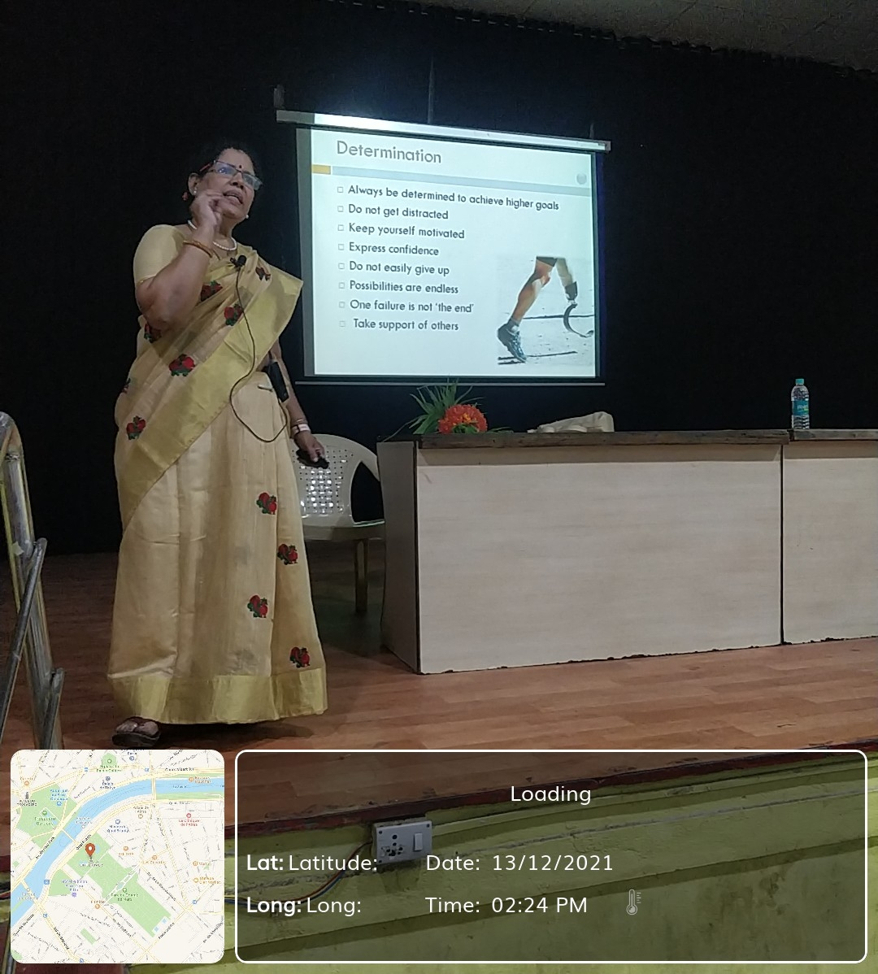
Day: 2 (14thDecember, 2021)
Ms. Mridulatha began the session on resume writing with a story using which she explained how to portray each individual's strengths and intelligence. She then played a small game of offering a Cadbury to explain about grabbing an opportunity.
She then went on to explain the difference between Resume, curriculum vitae, biodata and profile in a very simple way. She explained in detail how important it is for a resume to ‘scream out’ one’s potential, strengths and how we are an asset to the employer in 30 seconds or less. She explained each step clearly by involving student volunteers, calling them on to the dais and giving them hands-on training on all steps involved in highlighting their strengths in the resume such as writing a clear objective, educational qualifications in reverse chronological order, technical skills etc.
It was greatly interactive where students played games to identify their positive qualities. The students went back equipped with knowledge on portraying themselves positively through their resume.
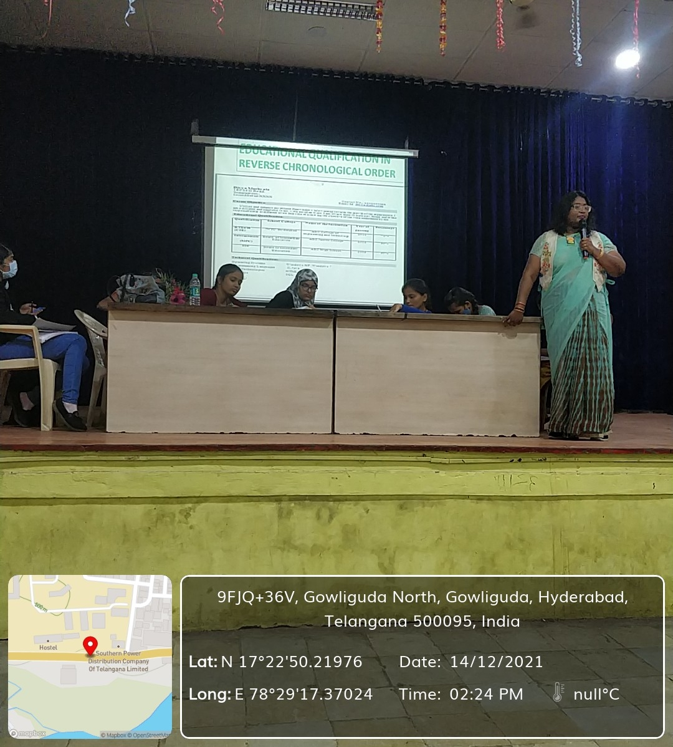
Day 3: (15thDecember, 2021)
The third session of the series was on Communication Skills and Body Language by Ms. Ramya Raman. Right at the beginning, she made sure that the students were comfortable and at ease by conducting a small activity.
The activity introduced the students the strategies of communicating with different strata of people. It also helped explain the difference between communication and effective communication, and how good communicators are also good influencers.
She taught the students how to present themselves convincingly to employers and to strategize communicating effectively, by giving everyday scenarios of communication as examples. She went on to discuss the 5 Ws and 1 H of effective communication, and how these dictate the rules of effective communication.
She further discussed about the types of communication- oral, written and body language and the rules that govern each type of communication like the 3Vs and 7Cs and how to use these skills to make the opportunity count during an interview.
The session was thoroughly enjoyed as the activities and examples were absolutely relatable to their level.
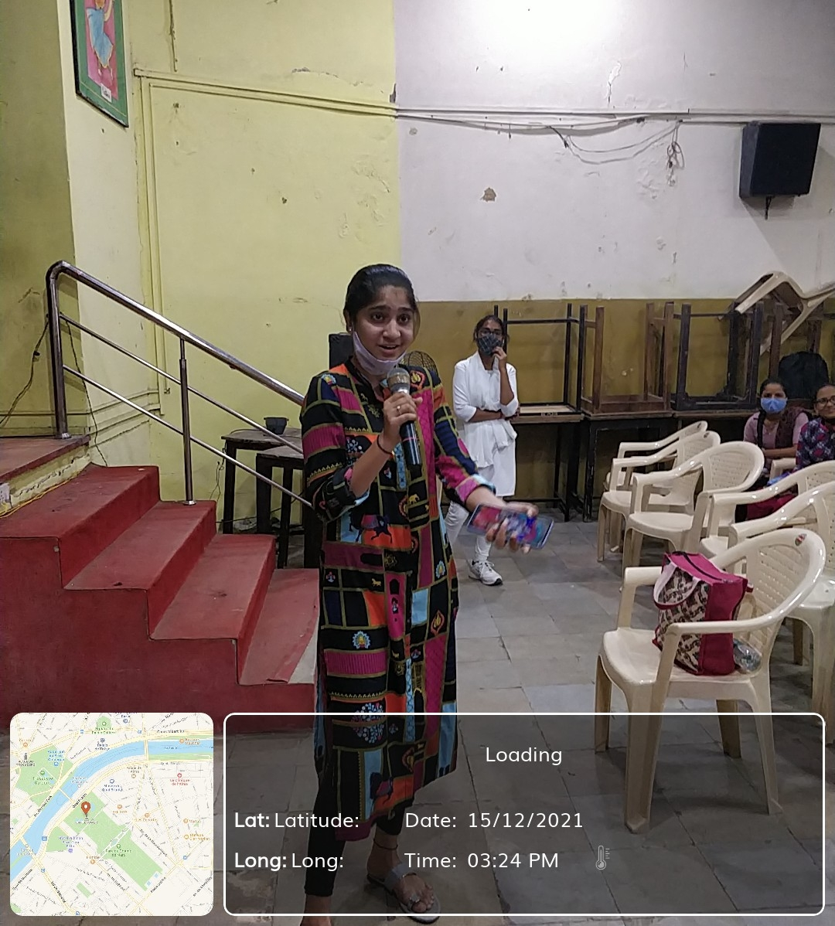

Day 4: (16thDecember, 2021)
Mr. Sudheer Sandra, the fourth speaker of the series, spoke on the topic ‘Leadership skills and team building’. He began the session by making the students sit up actively by quickly asking a few questions.
He opened up doors to skills which helps students fulfill their professional ambitions and live a rich life by introducing a concept called 6:8 that is 6 points and 8 thought provoking questions.
He conducted many activities to help the students understand and assess their key leadership qualities and realize the importance of self-motivation and self-drive to achieve dreams and goals.
The session was attended by the students who enthusiastically participated in the brain stimulating games and thought provoking activities and was extremely useful and interesting to all attendees, including teachers.

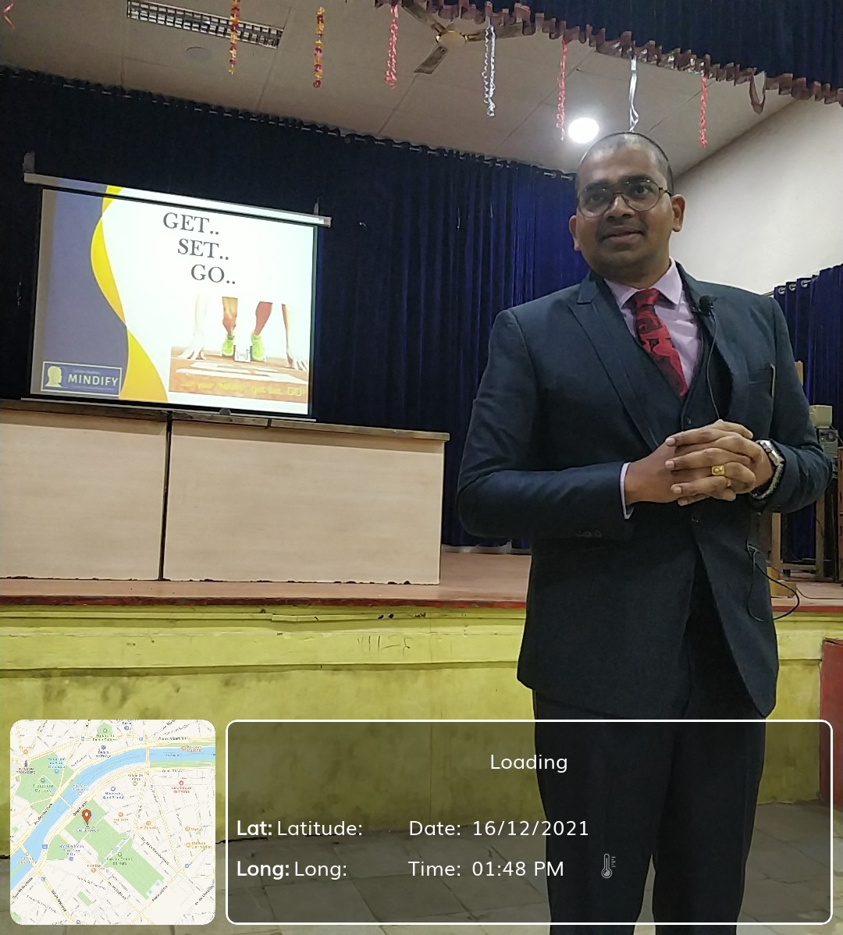
Day 5: (17th December, 2021)
The last session of Pre-Placement training had Prof. A. Kamalakar, president, Shapiro Foundation, Melbourne, Australia as the speaker. He launched straight into the topic ‘group discussion and interview skills'. He introduced the purpose, needs, advantages and rules of group discussion and also explained the criteria for evaluation during professional group discussions.
He clearly explained the qualities needed to impress during group discussion, starting with being a good listener and a team player. He then went on to describe all the above attributes in the perspective of interview skills.
He then conducted mock group discussions and mock interviews to make sure the students got hands-on training on attaining knowledge essential to succeed in an interview and further their career pursuits. The session was extremely insightful.

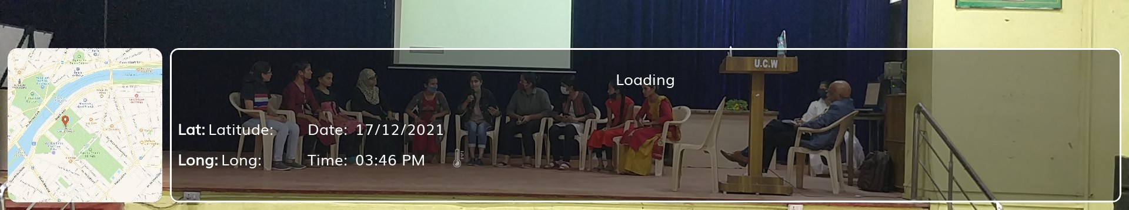

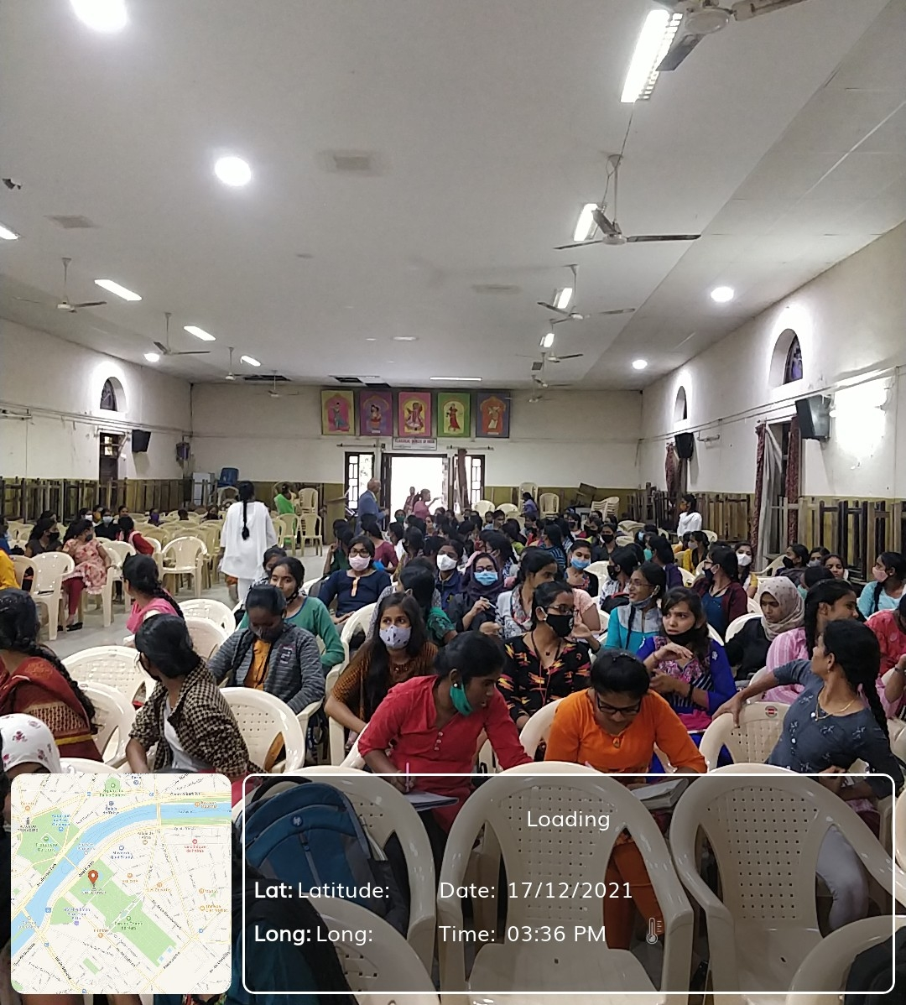
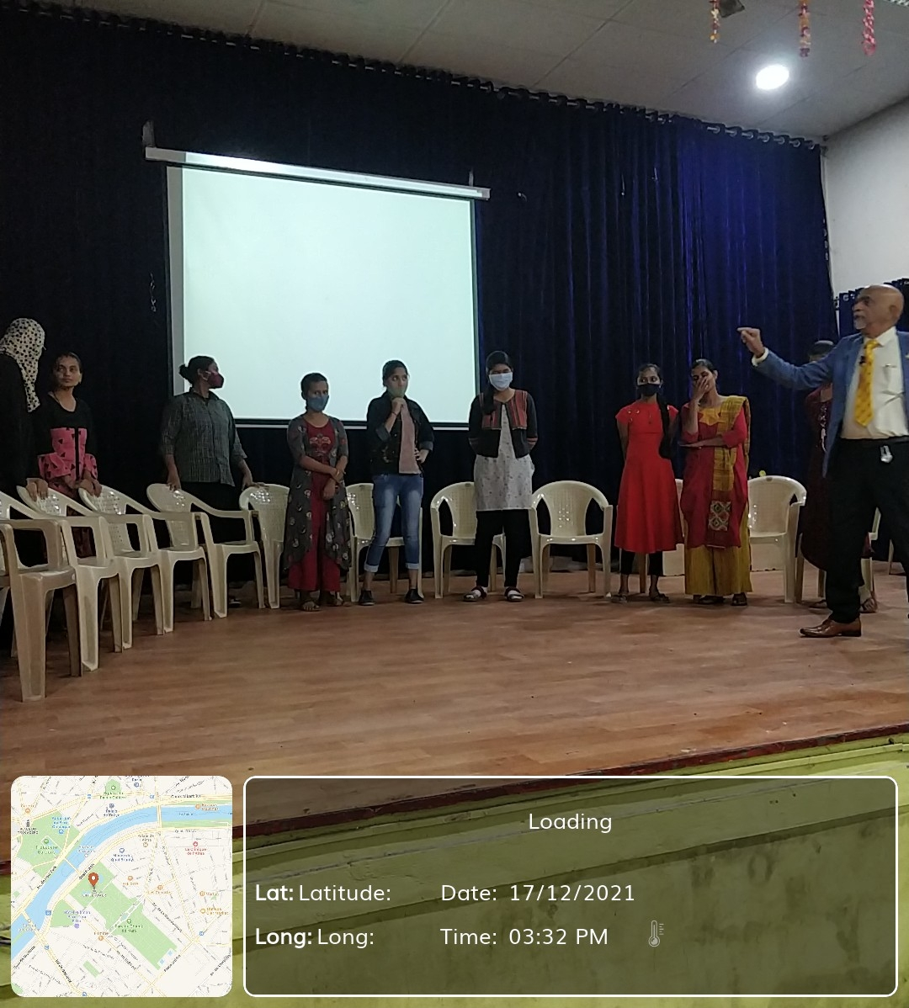
The pre-placement training program was attended by 292 students from UG and PG. The Pre-Placement Training Program was conducted successfully and majority of the participants took active part in the program. Overall, we had a wonderful experience by enlightening the students about the corporate world ethics. Not to forget, even we got to learn so much from them.
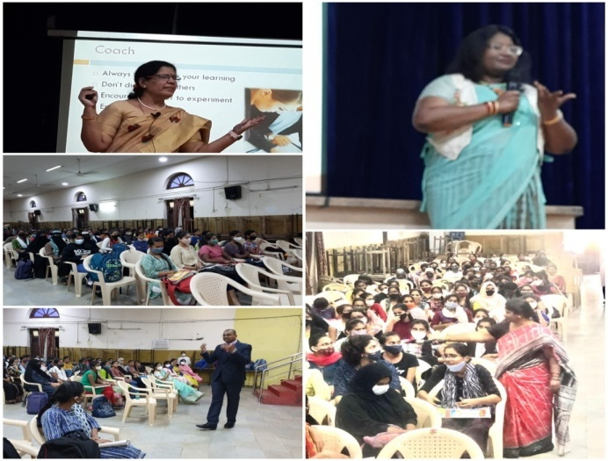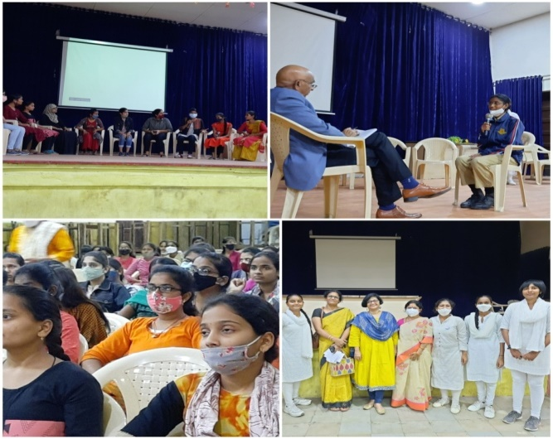

WORLD CONSUMER RIGHTS DAY – 15th MARCH 2022
The HCDC and IQAC, UCW, Koti in collaboration with Ministry of Marketing and Inspection, Ministry of Agriculture and Farmers welfare, GOI celebrated World Consumer Rights day on 15th March, 2022 at PG Seminar Hall, UCW.
The inaugural session began with the address by Prof. M. Vijjulatha, Principal, UCW. She explained the significance of knowing consumer rights and how the knowledge can help one in their day-to-day life. Dr. Sabiha Shareef, Vice-Principal (Hostels) shared her views on the ‘Fair Digital Finance’ the theme for the year 2022. The Keynote address was delivered by Dr. Anilkumar. R, Dy. AMA, DMI, RO, Hyderabad. He elaborated on the efforts put forward by the DMI in bringing awareness on consumer rights and the significance of hallmarking done for agricultural goods. He offered to collaborate with the institution for future awareness programs. Mr. Sampath Kumar, Regional coordinator, CATCO addressed on the importance of how various consumer organizations come together in getting justice for the disputes related to consumer rights. Dr. Rupasree along with the students of the choir group of UCW sang consumer awareness songs and jingles to make the concept more reachable and entertaining to the audience. The inaugural session ended with felicitation of the guests followed by the technical sessions.
For the technical sessions, speakers from various organizations who are experts in the subject were arranged. Sri.Vijaya Kumar, Deputy Food Controller, FSSAI, Hyderabad gave an elaborate explanation on the numerous activities carried out by FSSAI in bringing awareness to both consumers and vendors. He explained how they organize various workshops to enlighten even street vendors about consumer rights and why it is important to maintain cleanliness standards while selling food items. Sri. Siva Prasad, Scientist D, Bureau of Indian Standards, Hyderabad threw light on how BIS is involved in hallmarking all goods. He elaborated on what consumers have to look for when they purchase products from the market and also explained about various apps that are available to the consumers for easy redress. Smt. Vijaya Sagi, Advocate, Hyderabad, emphasized on the various laws made to safeguard the consumer rights. Her lecture also gave an insight into the need of reporting any improper goods sold or purchased by consumers. Sri. Krishna Gokle, Marketing officer, DMI gave an idea about all the efforts put forward by the DMI in giving Agmark seal for various goods.
Mrs. Jayasurya Kumari, FSM, Dept of Chemistry along with her students demonstrated simple tests that can be performed to identify common food adulterants. This was a much needed session for the students as the demonstrations were meant to throw light on how one can assess the purity of some common food items purchased from the market.
The program was attended by nearly 175 students from various streams. The technical sessions and the live demonstration helped the students learn about consumer rights thoroughly. Overall the program justified the theme and concept of the consumer day celebration.
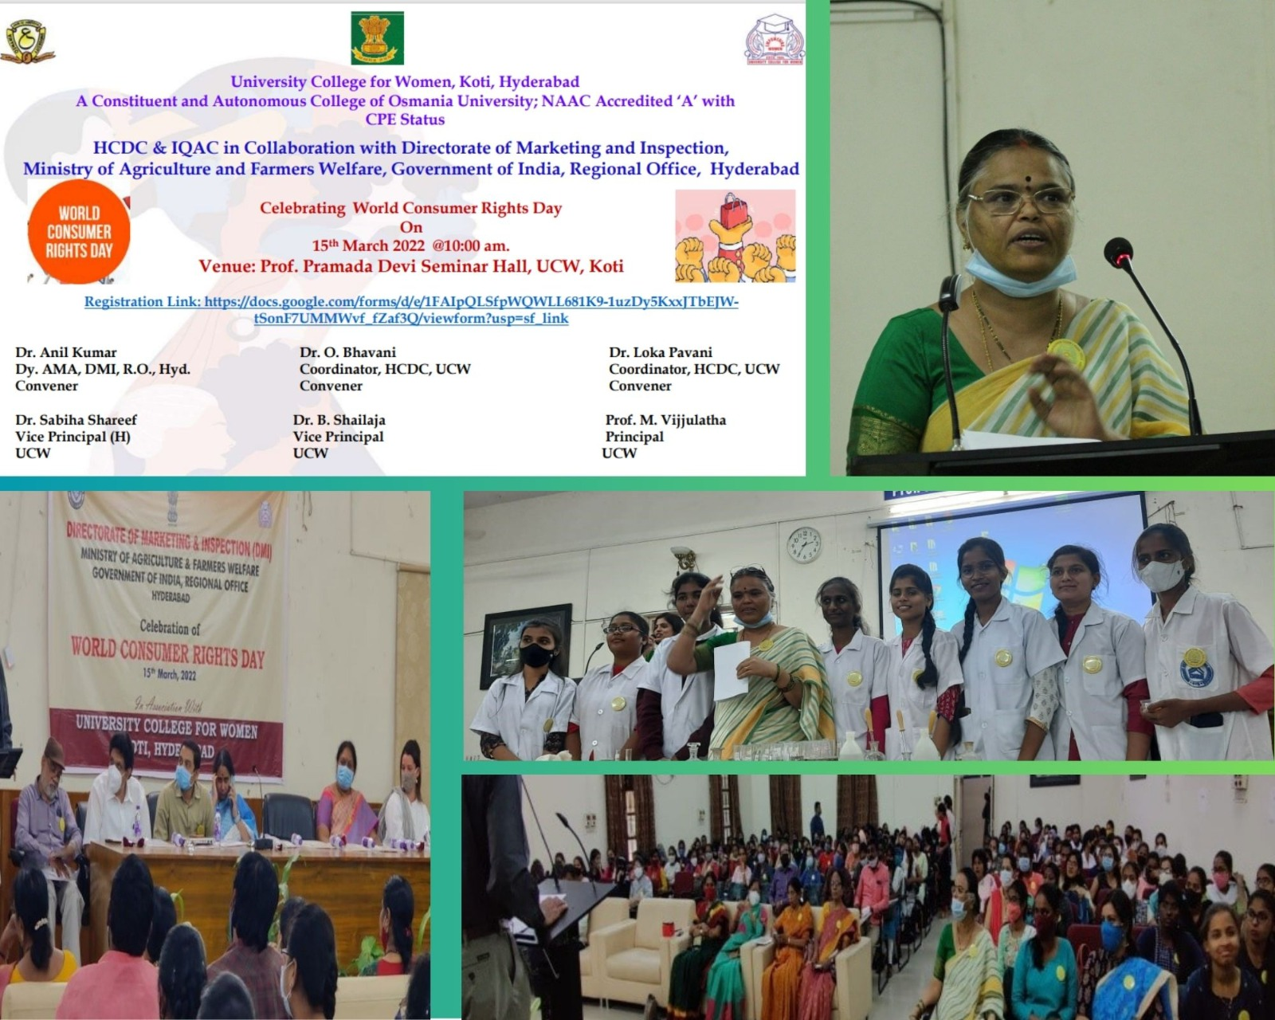

AWARENESS PROGRAM ON IPR: 21st MARCH 2022
IQAC, HCDC and SEDC, University College for Women in association with Patents office, Government of India under NIPAM organized a one-day seminar on Intellectual property rights on 21st March, 2022.
The speaker of the seminar, Dr. Ayodhya Dasari, Examiner of Patents and Designs, Ministry of Commerce, Government of India began by explaining difference between Research and patents, and then went on to define the term Intellectual Property Rights (IPR).
He then elaborately discussed the seven types of IPR like patents, Design, Trademark, Copyright, Geographic Indication and Trade Secrets. After discussing as to who can apply for IPR, he explained about the types of patents like personal, business, license or franchise and further discussed the process of identifying and filing the patents in India. He also explained how a single product, like a laptop,can carry 5 different patents. He also discussed about online and physical filing of an application.
He showed the attendees a few pictures and asked them to identify the type of patents applicable to the pictures. The attendees participated with a lot of enthusiasm. He cited different examples of Patents filed by middle and high school children, including smiley box design, to inspire the audience and it was very well received.
In conclusion, he motivated the students to become young innovators and file patents to ensure quality output in the country. The session was attended by 334 faculty members, U.G and P.G students. The session was extremely informative and was thoroughly enjoyed by all attendees.
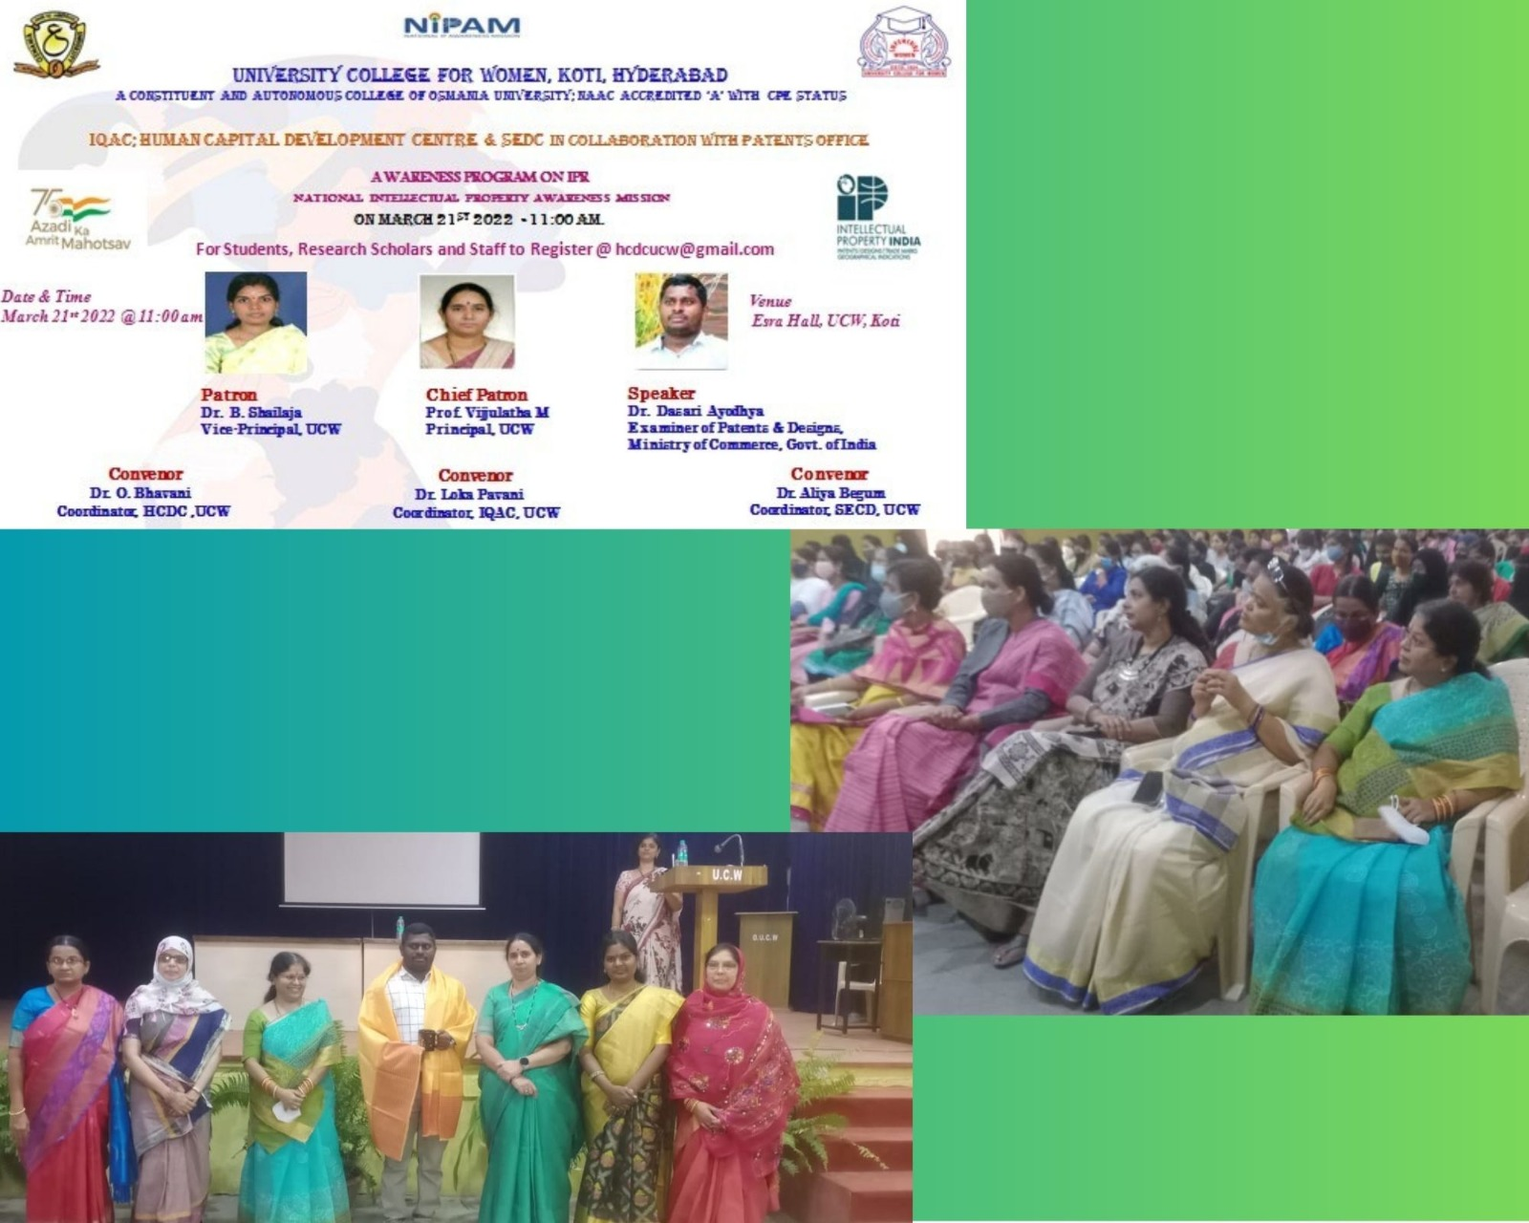

UNLEASH THE POWER WITHIN- 24th March, 2022
The HCDC and IQAC, UCW in collaboration with Goldman Sachs and WICCI organized a program titled ‘Unleash the power within’, a session of inspirational talks by empowered women on 24th March, 2022 at PG seminar hall, UCW.
Prior to organizing the talks, the students were asked to write one question each on the tagline “How I wish I know”. More than 600 students from all over the college responded with varied responses which were addressed by the speakers on the day of the program. The program had 3 women speakers. Ms. Deepika Benarjee, and Ms. Archana Tayade from GS and Ms. S. Mridula from WICCI.
The session was conducted by Dr.K.S.N. Jyothi, program coordinator and member HCDC, UCW and Ms. Anupriya from GS. Principal, Prof. M. Vijjulatha, Vice Principals Dr. B. Shailaja and Dr.Sabiha Shareef, Coordinator, HCDC, Dr. O. Bhavani, Coordinator IQAC, Dr. Lokapavani, were all part of the event.
All the three speakers emphasized on the importance of self-worth, self-respect. They all shared their personal life experiences of how to overcome the challenges and climb up the ladder of success. They motivated all the girls to dream big and strive to achieve them come what may. Many students interacted with the speakers and clarified their queries. They took inputs on how to overcome barrier of language, financial constraints and how to convince parents about their life changing decisions. The program was highly appreciated by the students.

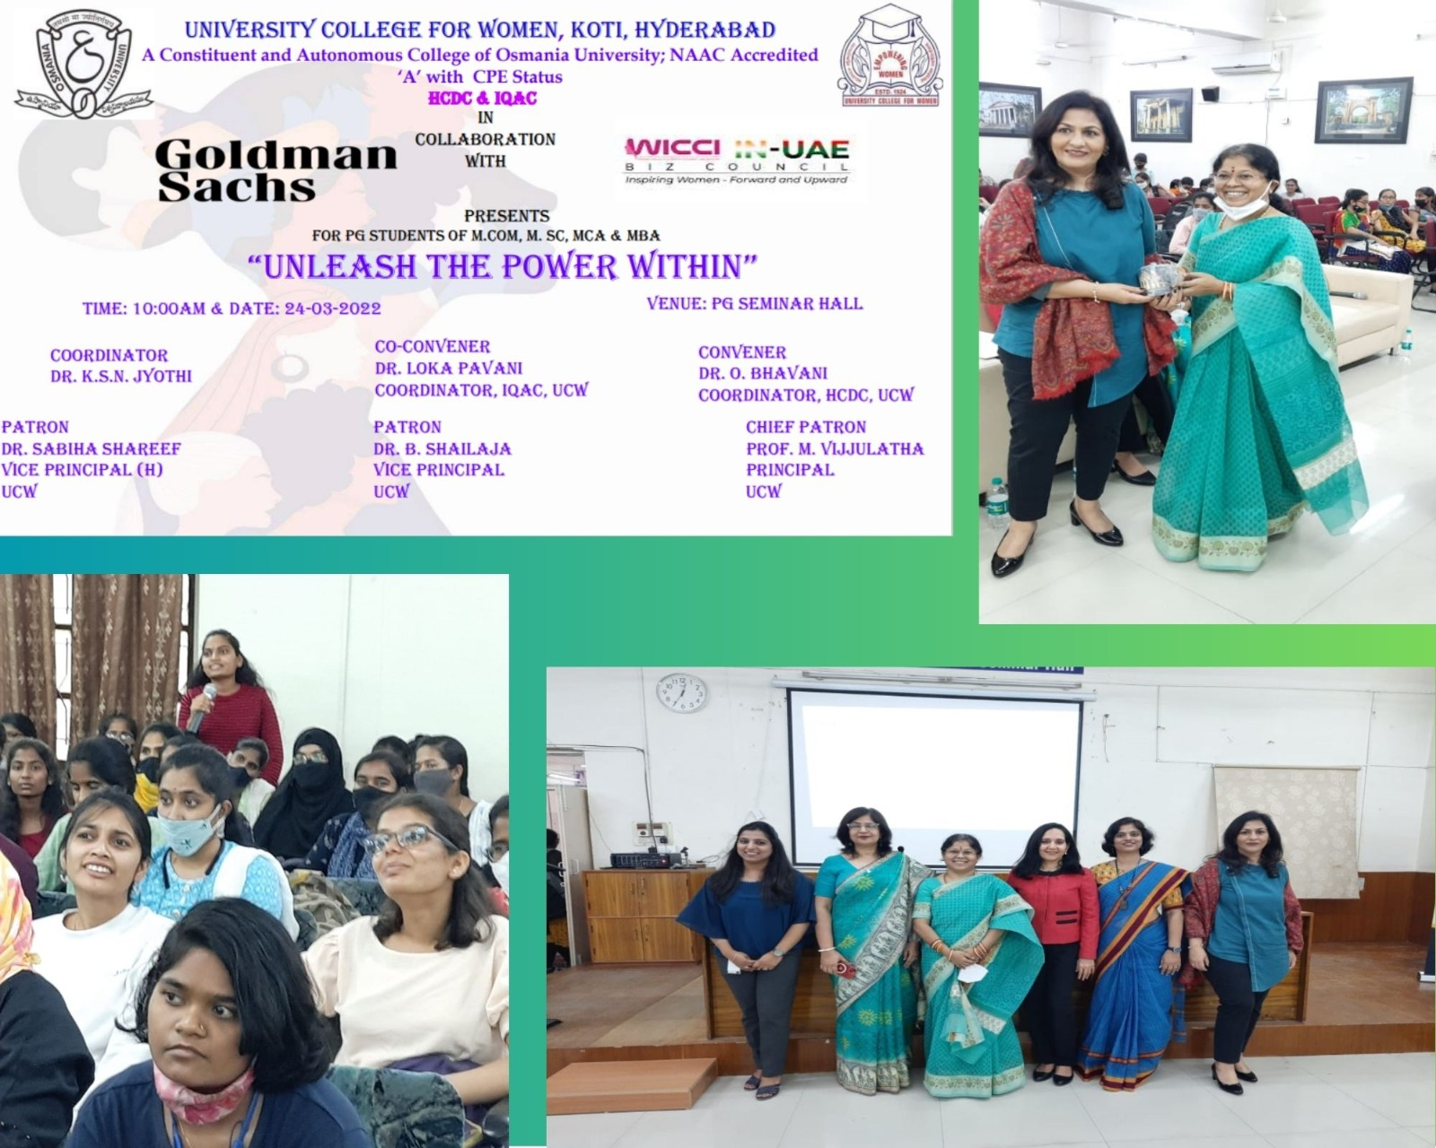
TRAINING PROGRAM ON EMPLOYABILITY SKILLS, 24th -26th MARCH 2022
The HCDC organized a three day program on employability skills in association with Nandi foundation, Mahindra pride class room for Undergraduate students of II and IV semesters from 24th to 26th march, 22.
The workshop covered various topics on the necessary skills required by the students such as Problem solving, team building and leading, situational response management and communication. Eminent trainers from Nandi foundation shared their expertise on the said topics and encouraged the students to interact, ask questions and share their views.
The sessions have been aptly timed as they exposed students to real life problem management and helped them realize their potential in handling situations. The sessions were attended by 350 students and were thoroughly enjoyed by them.
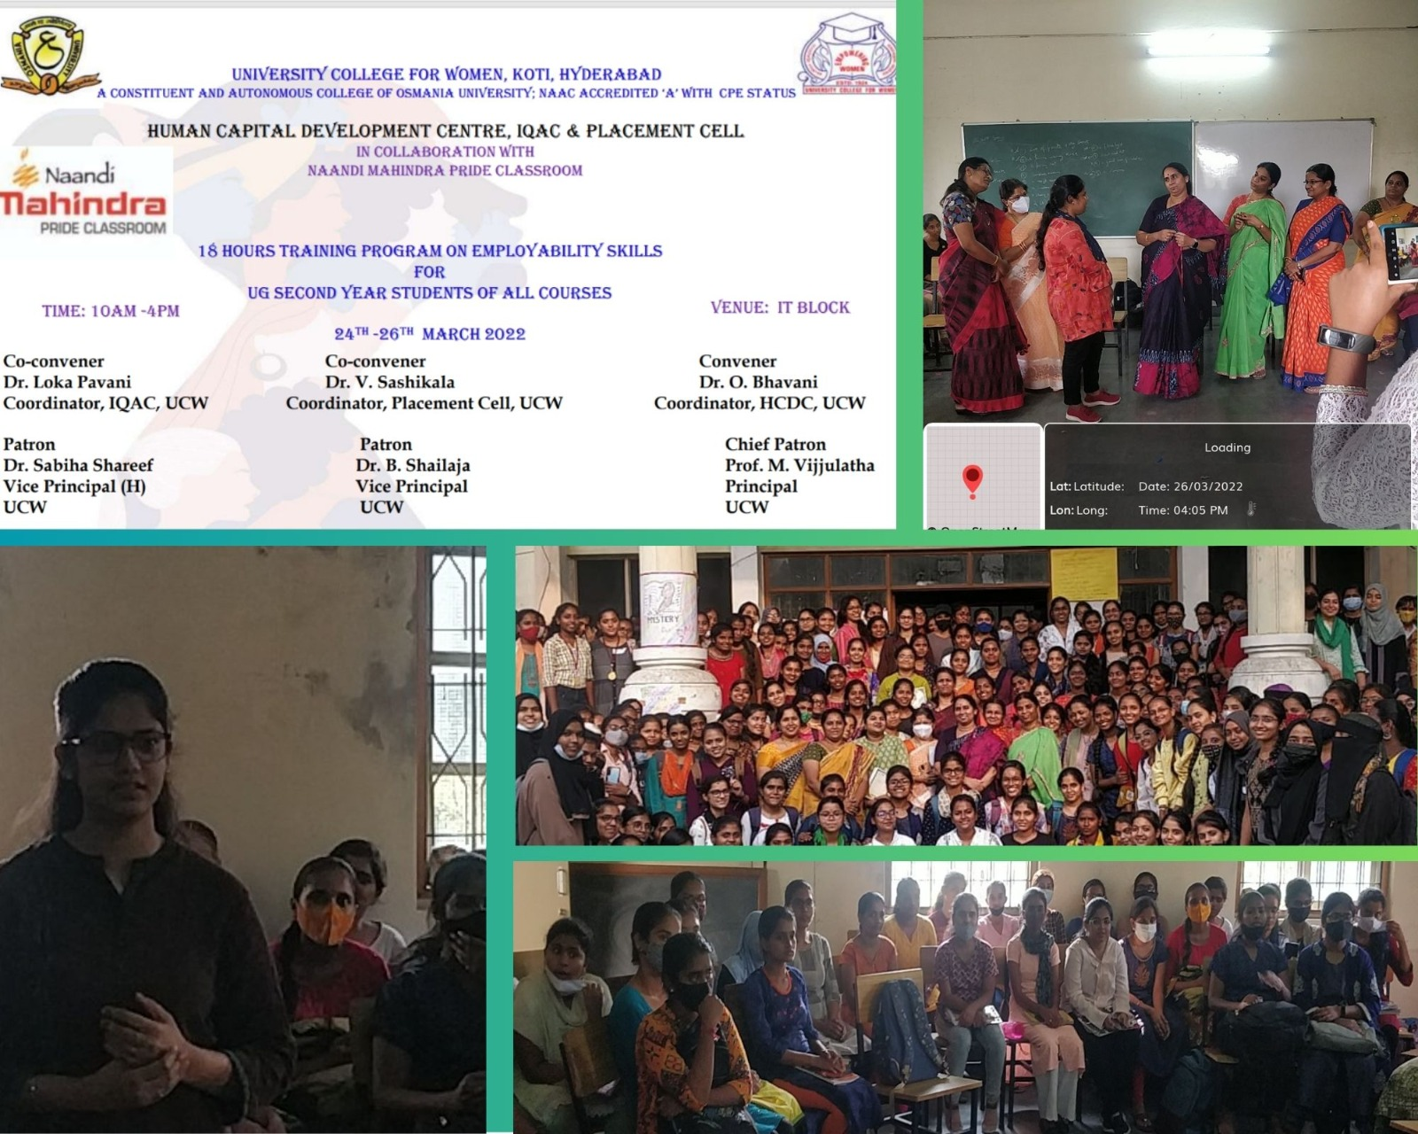

WORKSHOP ON ENRICHMENT ND EMPLOYABILITY- 21st to 23rd APRIL 2022
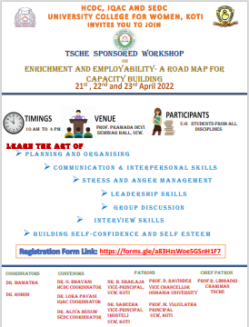
The inaugural for the three Day workshop titled “Enrichment and Employability -A Roadmap for Capacity Building” was held at Pramada Devi Seminar Hall on 21st April 2022
Principal - Prof. M. Vijjulatha, Vice principal - Dr. B. Shailaja, Vice principal (Hostel)- Dr. Sabiha Shareef, SEDC coordinator and convener - Dr. Aliya Begum, IQAC coordinator and convener Dr. Lokapavani- , HCDC coordinator and convener Dr. O. Bhavani, organizing committee members and students were all part of the Inaugural Session.
The programme began with Dr. Aliya Begum, who explained about the significance of the Three Day Program. Principal and all other members explained about the importance of various skills required for the academicand personnel excellence of students. They all motivated the students with their inspiring speeches. The inaugural session ended with an informal vote of thanks
Day 1 – 21st April 2022
SESSION – I: Leadership Skills: Dr. Parimala
A PowerPoint presentation on Leadership skills was started by Dr, Parimala highlighting the qualities that are essential to become an efficient leader. She carried the students along with her energetic talk and the session was continued by Dr. O. Bhavani, Dr. Alia Begum and Mrs. Sangeetha. Overall, the session was full of energy and activity.
SESSION – II: What industry is looking for in graduates: Dr. Abhiram Krishna S
Dr. Abhiram Krishna S specified the strategies such as Nurture hobbies; enhance resume value, leadership ability, staying updated, effective utilization of Face book, Linkedin etc which will help the students to land in the profession of their choice. .He emphasized about the list of expectations the employers look for at the time of interviewing the candidate. He further added that the behavior, feelings, belief system, value system and self image plays a key role in reaching the altitude of success in life. He involved the students actively by motivating them to participate in the discussion through chocolate distribution.
SESSION – III: Interpersonal Skills: Mr. K. V. Pradeep
A continuous learner and creative thinker who is doing character role in films and serials, Mr. K. V. Pradeep who is known for his original idea production and humorous articulation motivated the students through slogans- Getting- Forgetting, Giving-Forgiving by explaining elaborately about inter and intra personal skills. Students have actively participated in all aspects with good understanding and committed to attain perfection through practice.

Day 2: 22nd April 2022
SESSION – IV: Emotional Intelligence: – Dr. Kota Tripatiah
Dr. Kota Tripatiah explained that emotional intelligence is the ability to perceive, understand, manage and handle emotions. He emphasized on the five key elements such as self-awareness, self-regulation, motivation, empathy and social skills that plays an important role in building emotional intelligence. He quoted examples such as –being able to say No when you need to and being able to solve problems in ways that work for everyone to become emotionally intelligent.
SESSION – V: Self Esteem & Self Confidence: –Dr. C. V. Ranjani
Dr. C. V. Ranjani is an Associate Professor, Department of Commerce, Osmania University. She sighted many examples that proved that if we speak good words, it will have a positive and good impact on us and we will be constantly motivated to inculcate strong self-esteem which will in turn make us confident and successful persons. Self-talk will help in gaining insights about ourselves and enhances our mental competency to cope up with stress and boosts team spirit and positive attitude towards life. It was a well addressed session beautifully supported by examples, anecdotes and also an interactive session well executed with participation in exercises.
SESSION –VI: Career Opportunities: –Dr. Chandrashekher
Dr. Chandrashekher focussed on leadership qualities, social responsibilities and academic qualification of a student which are essential for procuring a job. Also, soft skills, organizational skills and technical skills are helpful for identifying as a potential and competent job-seeker by any Institution at an interview. New learning approach should be adopted by the students moving from conventional to modern technology such as learning Apps and experiential learning methodologies. He also pointed out how the students should set their goals in building up their career in this advanced society which is changing every second. He concluded the session by focusing on how the students have to change their reading; analysing and thinking styles in order to achieve their dream job.

SESSION – VII: A Roadmap for Students’ Innovation: –Dr. Viswanadham D
Dr. Viswanadham D, currently working as AVP and Head –Life Sciences incubation, IKP knowledge park was happy to visit University College for Women and explained about various funding agencies which support innovation ideas of students and faculties to come into reality. His session was lively and interactive. He agreed to train few of our students and faculty. He interacted with the students, explained them with examples how an idea can be shaped into a startup and transform it into an enterprise, which was received with a lot of enthusiasm from the students. He also distributed calendars and masks to students to encourage their participation and involvement in Start-ups.

Day 3: 23rd April 2022
SESSION – VIII: Stress & Anger Management: Dr. Sridhar Raj
Dr. Sridhar Raj is a resourceful personality from IPE. He started off with Laughing and emphasised on energising our bodies by stress and anger management. He advised the students to have positive affirmation that every individual should keep repeating to oneself that she is healthy, special, perfect, powerful, intelligent, strong and confident person, with unique talent to prove that she can achieve the goals. He counseled persons on psychological issues relating to Stress Management, Depression, Life Transition, and various Career issues.
SESSION – IX& X: Interview Skills & Group Discussion: - Mr. G. Bala Krishnan
Mr. G. Bala Krishnan is a Audit talent lead and Audit learning & development leader at Deloitte Haskins & sells LLP. He emphasized on the skills required to face interviews at corporate level. He expressed that individuals are born with various skills and abilities. Individuals need to explore these hidden talents through self-introspection and self-awareness. He conducted mock interview and involved students in effective group discussion.
VALEDICTORY FUNCTION
The Valedictory function began in the afternoon session with a brief report by Dr. O. Bhavani Program Convener and announced that about 200 students have participated in the program . Altogether about 10 sessions were held on large variety of topics like Interpersonal Skills, Emotional Intelligence, Self Esteem & Self Confidence, Stress & Anger Management, Interview Skills etc. Next, the messages by Dr. Aliya Begum, Program Convener Dr. Sabiha Shareef, Vice Principal (Hostels), Dr. B. Shailaja, Vice Principal were delivered. They have congratulated the organisers, committee members and the students for the grand success of the program. The program ended with the Vote of thanks by Dr. Lokapavani, IQAC Coordinator and program convener. The Certificates were distributed by the Registration Committee to all the students who participated in the Program.
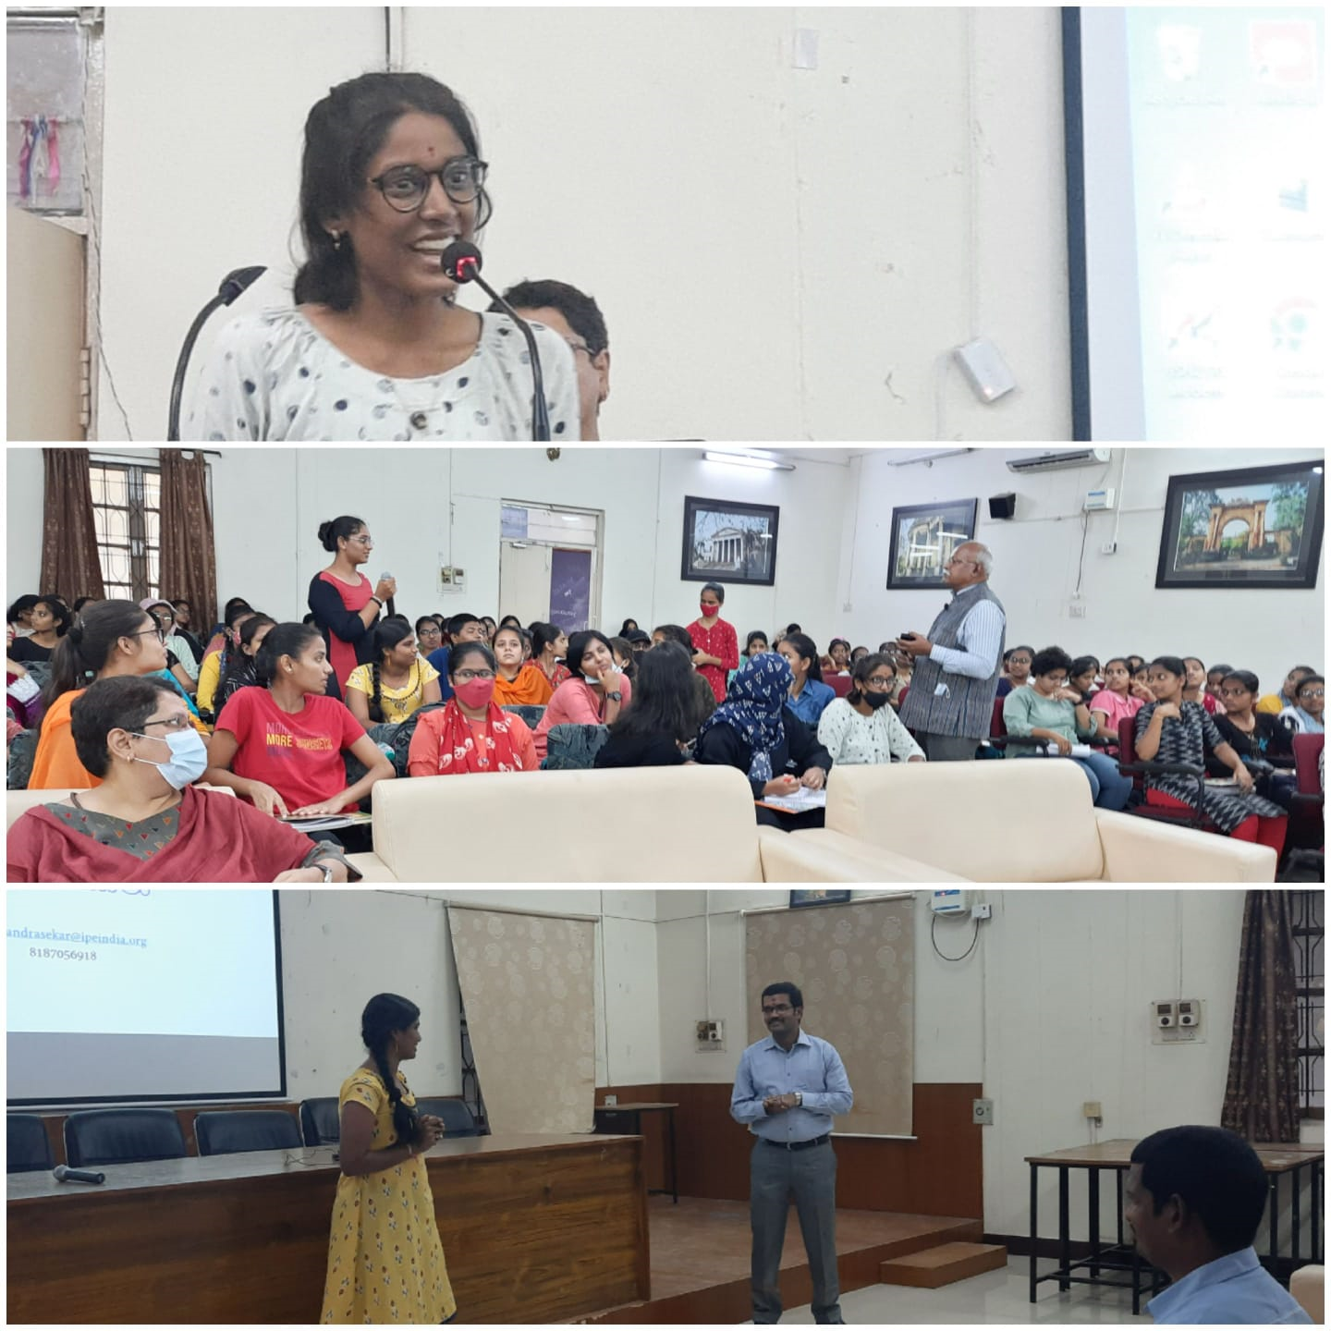
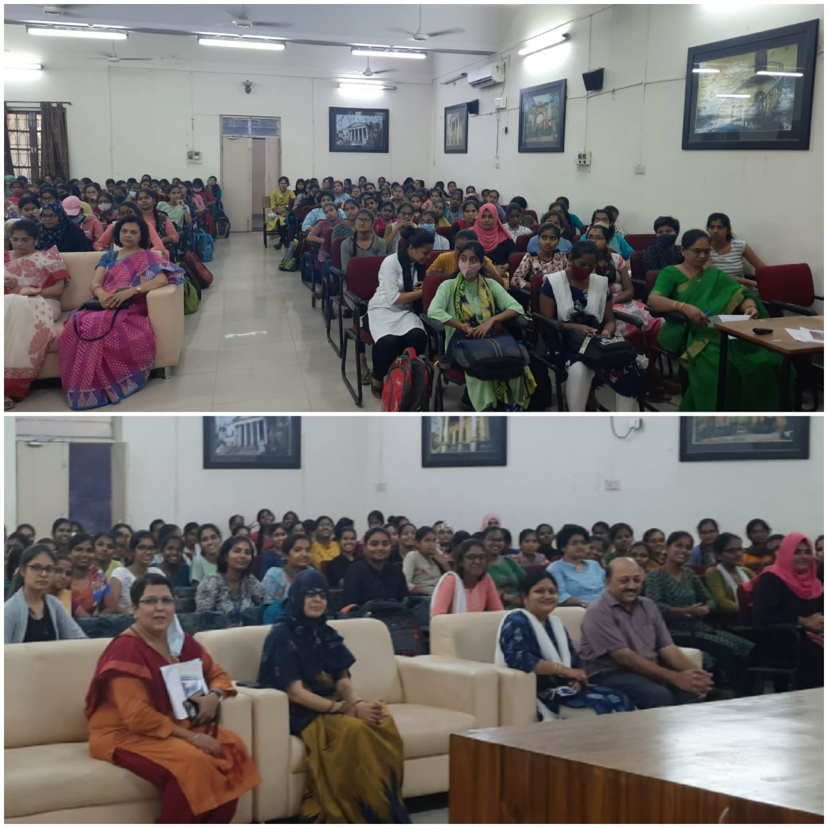
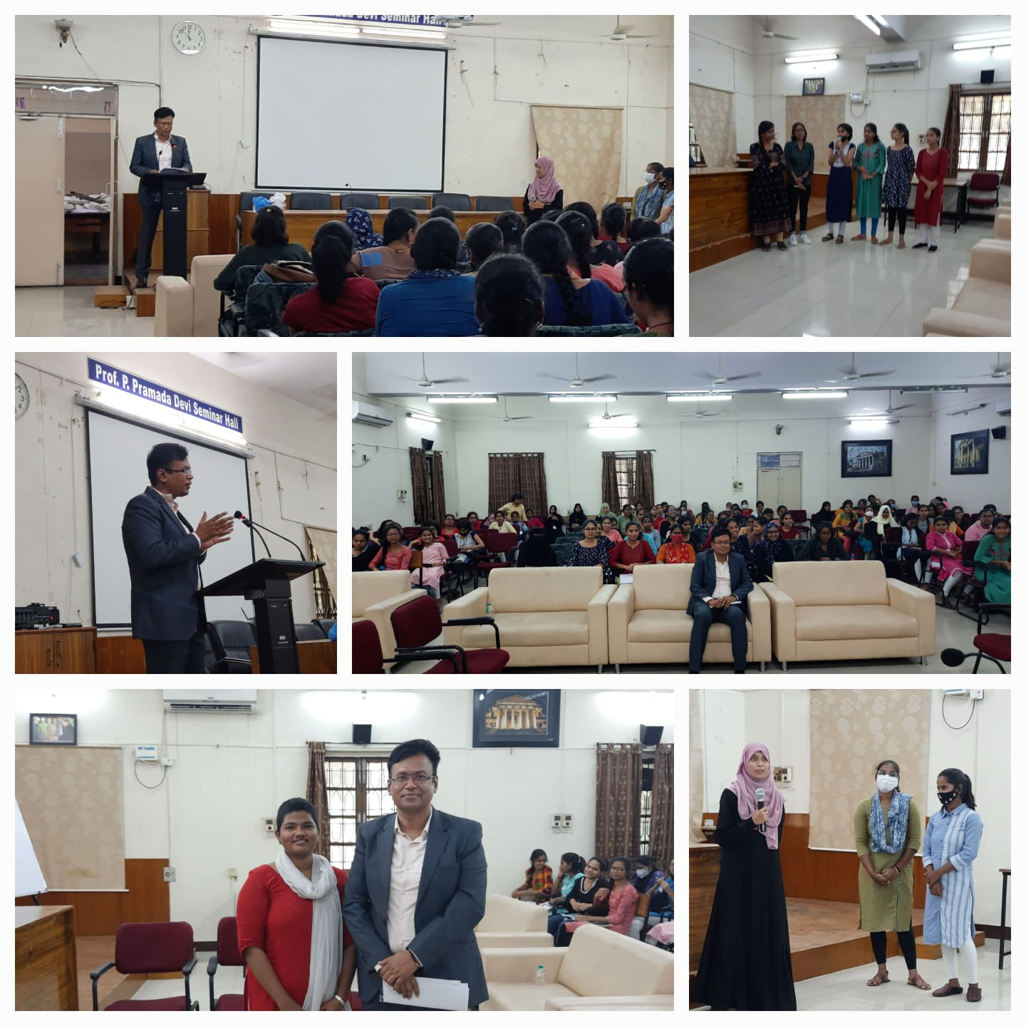
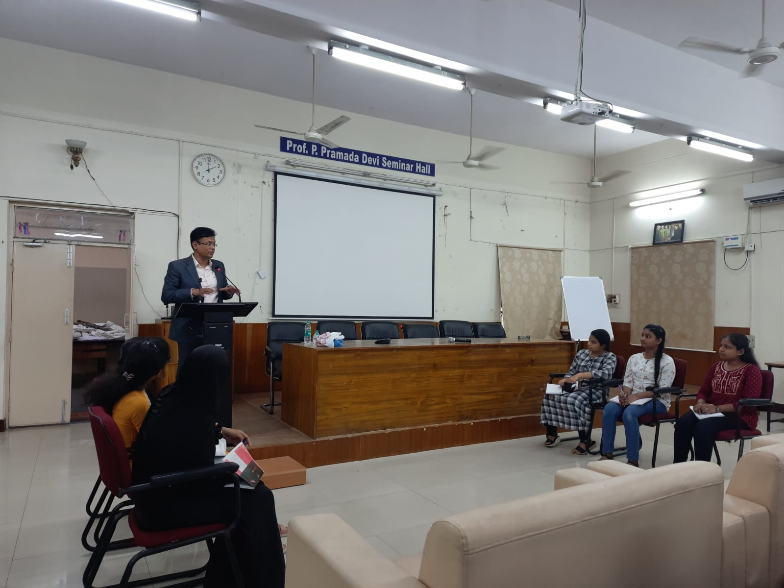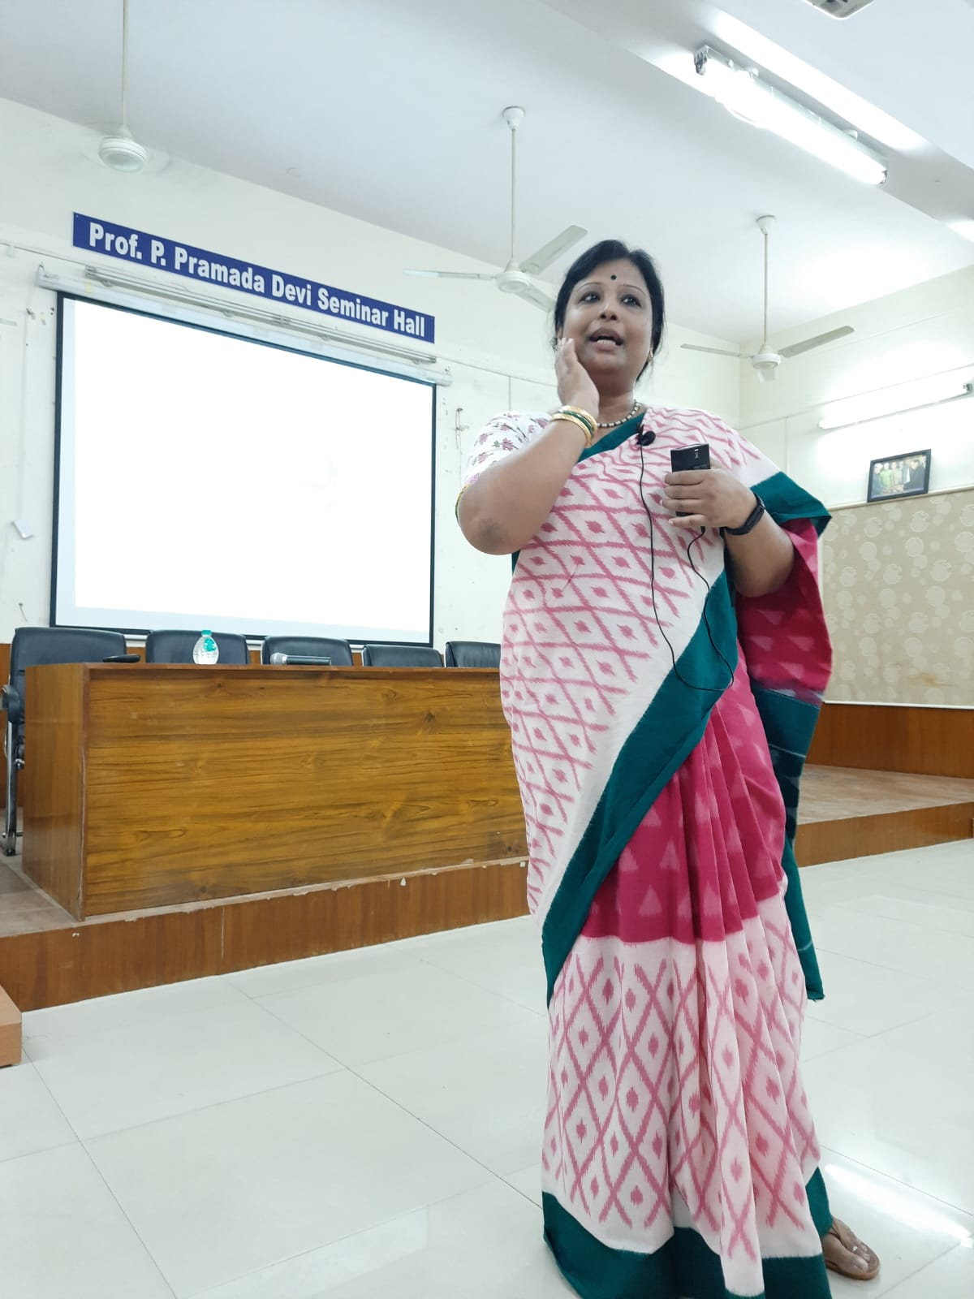
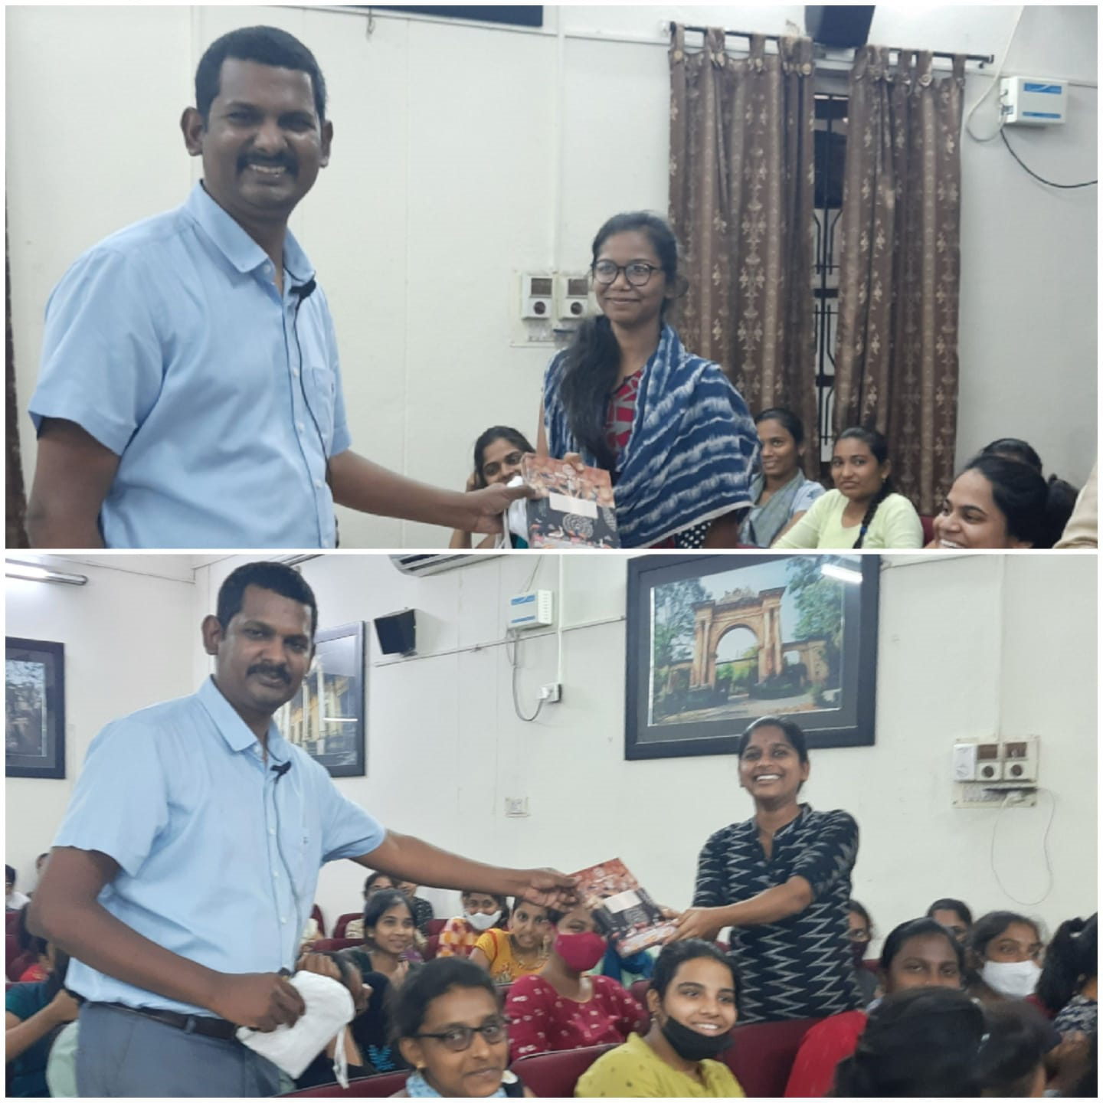

A ONE DAY PROGRAM ON RESEARCH TO THE CLASSROOM IN COLLABORATION WITH IPE ON APRIL 27th 2022
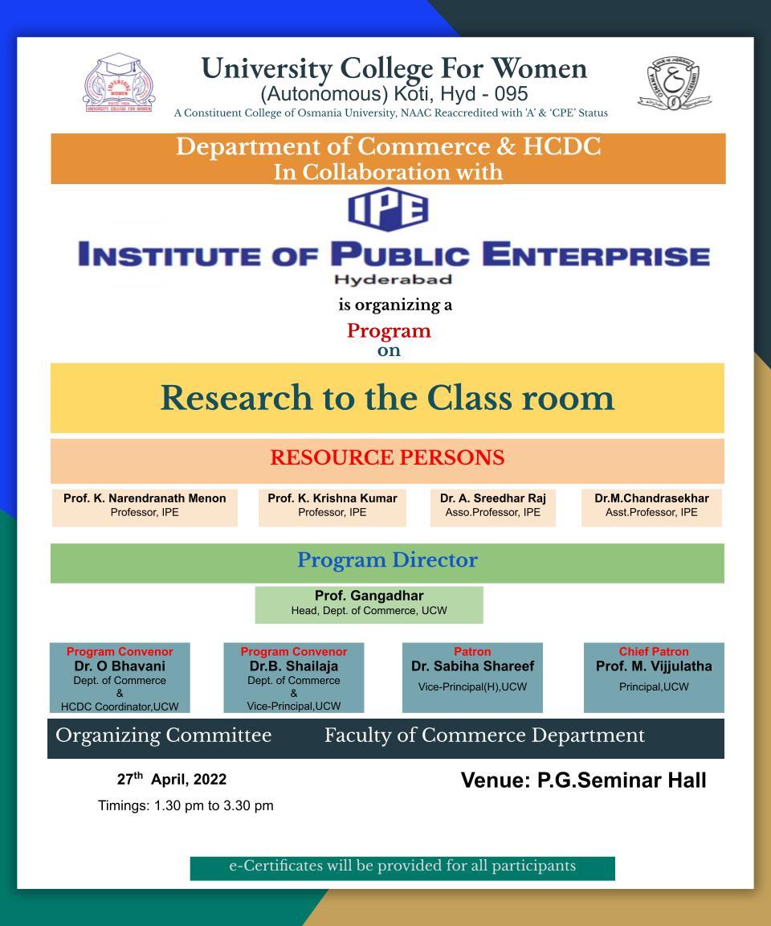
HCDC and Department of Commerce in collaboration with IPE has organised a program on Research to the Classroom for VI semester B. Com students of all streams. Prof. K. Krishna Kumar, Prof. Narendranath Menon, Dr. A. Sridhar Raj and Dr. M. Chandrashekar acted as the resource persons. The sessions focused on the guidelines for preparation and presentation of Project Report. The resource persons have elaborated on how the topics have to be selected for the project report, the importance of review of literature, organisation of the research work, identifying the research gap, framing of objectives, formulation of hypothesis, research methodology, data collection, tools and techniques, data analysis and interpretation; and references. The program was found interesting by the students as project report was part of their curriculum and they have to prepare for the award of bachelor’s degree.

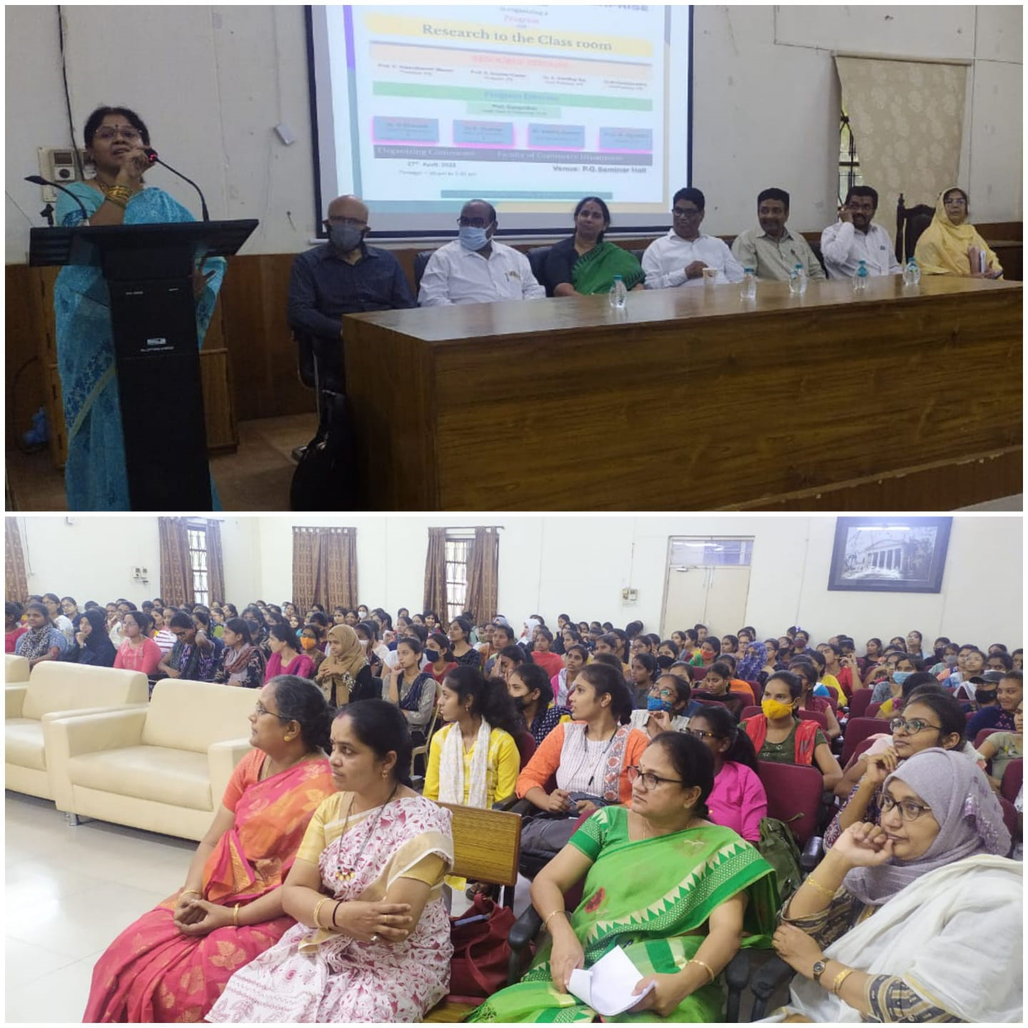

Coachig Classes for TSPSC Group I Services
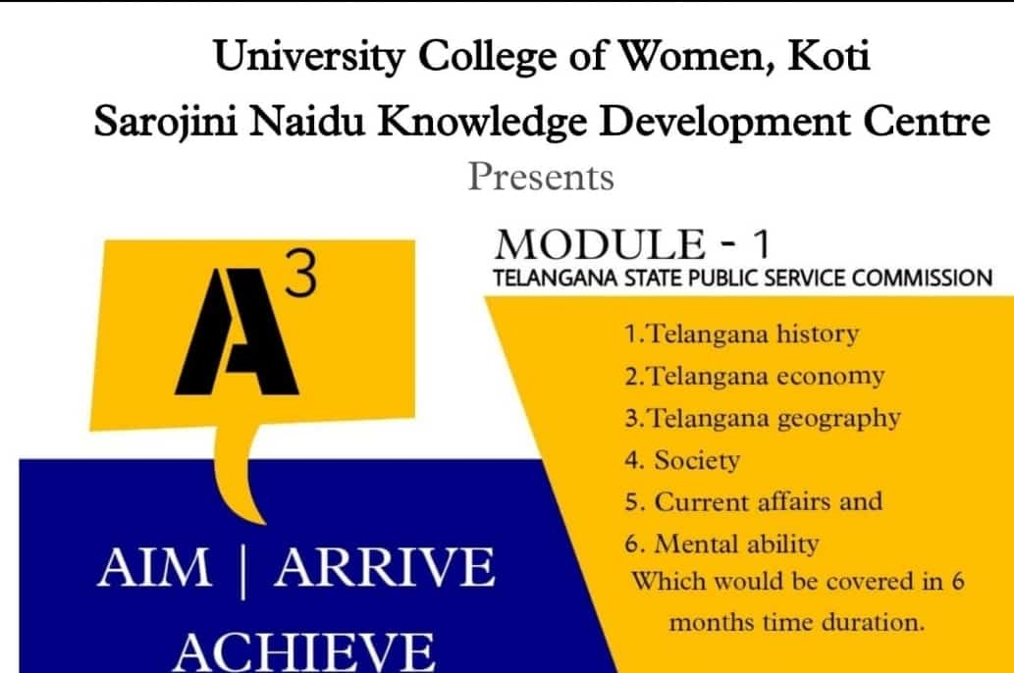
HCDC, in association with “TeamA3 has started classes for Telangana Group 1 services from 25/04/022 and completed the coaching in a span of 5 months as per the syllabus given by TSPSC.
The following members have engaged the classes:
- Mr. Saran - Polity and Telangana History and Telangana movement
- Mr. Sriram - Indian Economy
- Ms. Likitha - Indian Economy
- Mr. Rajshekar - Telangana Economy, Govt. schemes and Telangana culture
- Mr. Vamsi - Quant and Reasoning
- Mr. Harsha - Environment, Society and Current Affairs
- Mr. Tarun - Geography of India and Telangana
- Mrs. Gayatri -Science and Technology

Allotment of hours for subjects:
- Polity - 40 hours
- Indian Economy and Telangana economy - 60hours
- Indian and Telangana Geography -50hours
- Science and Technology - 20hours
- Environment - 25hours
- Society - 15hours
- Telangana movement, struggle and Telangana history -80hours
- Indian history - 50hours
- Current affairs and government schemes - 40hours
- Quant and reasoning - 40hours

The classes were conducted in both online and offline mode as per the students requirement and mock tests were conducted

